LOCAL NOTICE TO MARINERS NO. 24 of 2026
Hinkley Point C Marine Works Offshore Area –
Water Sampling Campaign
5th October 2026

Issued: 03/10/2026
Mariners are advised that commencing 5th October 2026 for 1 day, water sampling works will be undertaken within the HPC offshore area. Sampling will be carried out near the heads. Heads locations as shown in the chart extract below.

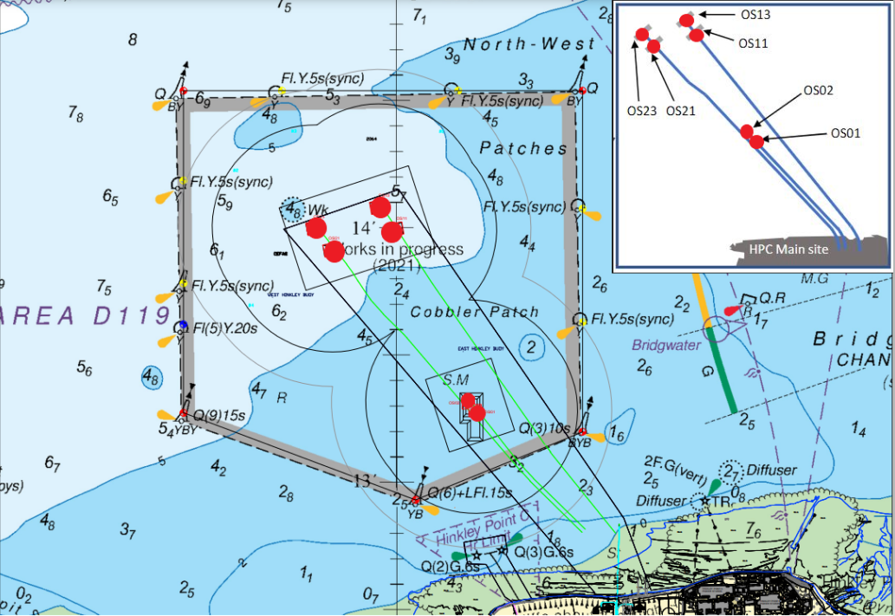
Chart extract of the HPC works in progress marine construction area, also highlighting in red under water obstructions.

The vessel “Osprey” (as detailed below) will be conducting these works and will be restricted in its ability to manoeuvre during operations.
The vessel will maintain a listening watch on VHF channel 16 with a working channel of 87.

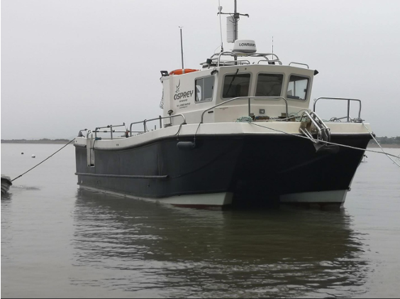

Name | Type of Vessel | Call Sign | MMSI Number | Length
Osprey | Catamaran | 2GGV3 | 23535097277 | 10m

Mariners should continue to avoid the Works in Progress area and keep well clear of ‘Osprey’ whilst these works are being conducted.

This Local Notice to Mariners is self-cancelling.
Harbour Master – Hinkley Point C Harbour Authority

