
LOCAL NOTICE TO MARINERS No. 09 OF 2025

Hinkley Point C Marine Works Offshore Area

Acoustic Deterrent Device and Buoy Deployment

Issued 03/06/25

NOTICE IS HEREBY GIVEN that from Wednesday 4th June 2025, weather permitting, and until Wednesday 11th June 2025, one of the acoustic receiver arrays listed in HPC HA LNTM 07 of 2025 will be repositioned, and Acoustic Deterrent Devices (ADDs) will be deployed in order to conduct trials of this equipment. The devices and buoys will be deployed within the HPC Marine Works Offshore Area (see Admiralty Charts 1151, 1152, and the chart extract below), with locations as shown in the schematic diagram below.

These additional arrays and buoys will remain in place, together with the existing receiver arrays and buoys, until mid-September 2025, when they will be recovered and this LNTM will be cancelled.

Mariners are advised to remain well clear during deployment and recovery, and to avoid anchoring in the vicinity of the equipment once laid. Mariners are requested to keep well clear of the marker buoys throughout the deployment period.

The arrangement will consist of 22 lines of acoustic receivers weighted on the seabed, and two sets of acoustic deterrent devices around two of the heads, marked by red polyform net buoys, as below:

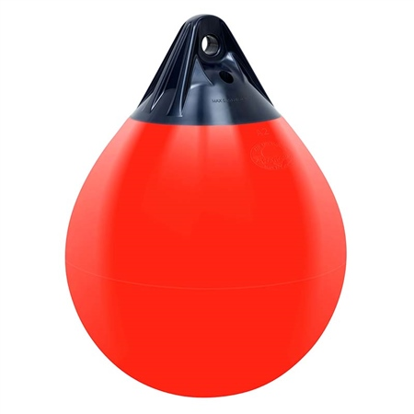

The area for the deployments is as indicated on the chart below:
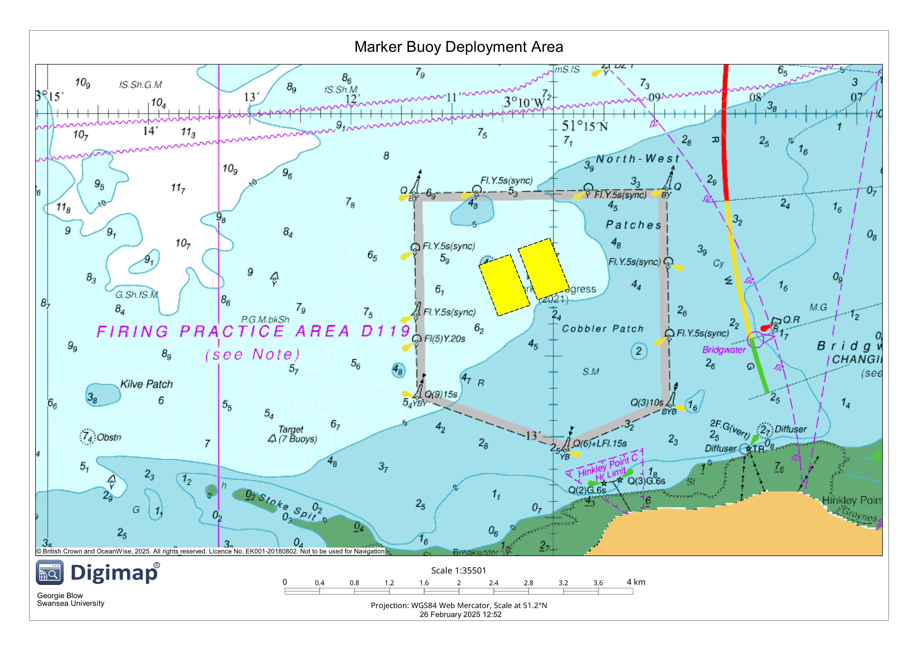

Schematic diagram of the equipment arrangement: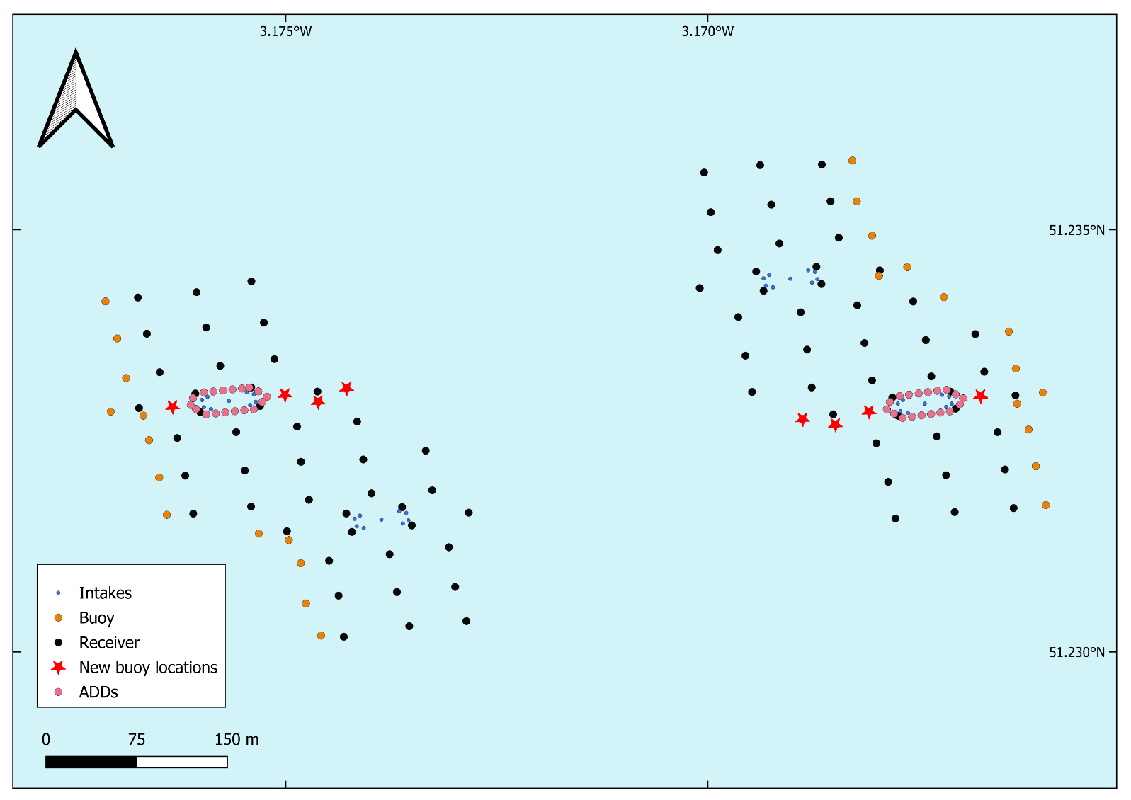

The equipment will be deployed from Port Tender “Alec D”, details below. During deployment and recovery the vessel undertaking the operation will be restricted in her ability to manoeuvre and will display the lights and shapes prescribed in the IRPCS (as amended).

Name | Type of vessel | Call sign | MMSI Number | Length | Photo
Alec D | Port Tender | ZISO5 | 235036673 | 17m | 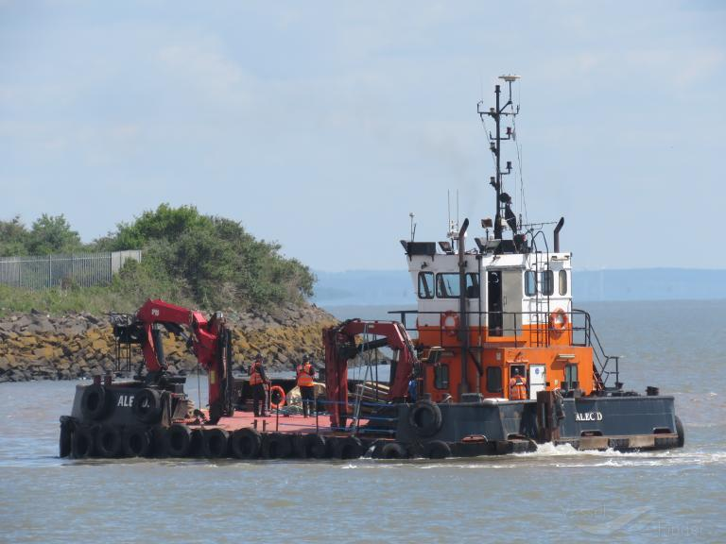

For any further safety advice, mariners are advised to contact the Duty Harbour Master

Harbour Master – Hinkley Point C Harbour Authority

Issued on behalf of Swansea University

EDF Energy - Nuclear New Build, Hinkley Point C, Somerset, TA5 1UF
Tel. 0333 009 7070 (24hr)
hinkley-enquiries@edf-energy.com
www.edfenergy.com/download-centre

